**CMSC 140 Programming Project 1**

**Chapters Covered:**

* Chapters 1, 2, and 3

**Concepts tested in this project**

* To work with cout and cin objects
* To work with variables, constants and literals
* To work with string object
* Use of different data types
* To follow programming style
* Use of basic arithmetic operators
* Use of output manipulators (setw, fixed, setprecision)

**Project Description**

The Department plans to purchase a humanoid robot. The Chairman would like you to write a program to show a greeting script the robot can use later. Your first task is to use the following script to prototype the robot for presentation:

|  |
| --- |
| *\*\*\*\*\*\*\*\*\*\*\*\*\*\*\*\* Robot Prototype Scripting \*\*\*\*\*\*\*\*\*\*\*\*\*\*\*\*\*\*\*\**  *Hello, welcome to Montgomery College! My name is Nao. May I have your name?*  ***john Smith***  *Nice to have you with us today, john Smith!*  *Let me impress you with a small game.*  *Give me the age of an important person or a pet to you.*  *Please give me only a number:*  ***2***  *You have entered 2.*  *If this is for a person, the age can be expressed as:*  *2 years*  *or 24 months*  *or about 720 days*  *or about 17280 hours*  *or about 1036800 minutes*  *or about 62208000 seconds.*  *If this is for a dog, it is 14 years old in human age.*  *If this is for a gold fish, it is 10 years old in human age.*  *Let's play another game, john Smith. Give me a whole number.*  ***4***  *Very well. Give me another whole number.*  ***5***  *Using the operator '+' in C++, the result of 4 + 5 is 9.*  *Using the operator '/', the result of 4 / 5 is 0*  *however, the result of 4.0 / 5.0 is about 0.8.*  *Thank you for testing my program!!*  *PROGRAMMER: Tina Lee*  *CMSC140 Common Project 1*  *Due Date: 2/10/2019* |

Write a program that uses the script above as a guide without roles, i.e. robot computer and visitor human, to prototype robot greeting in C++. See the Sample Screen Output below.

**Project Specifications**

Input

* Visitor’s name
* An age
* Two numbers

Output: The program should display the following data:

* Complete script described above
* Your name as the programmer
* Assignment/Project number
* Due date

**Processing Requirements**

1. The program should declare and initialize (i.e. create and assign values for) variables/constants to hold (at least) the following data:

* Robot Name. This variable will hold the Robot Name. Initialize the variable with “Nao” or a name of your choice.
* Visitor Name, this variable will hold the user’s name.
* Age. This variable will hold a person’s or a pet’s age.
* A constant variable for Programmer’s Name. Initialize the variable with your full name.
* A constant variable for Assignment Number. Initialize the variable with the value 1.
* A constant variable for Due Date. Initialize the variable with the due date of this assignment.
* Constant variables for Days of Month, Human Year, Gold Fish Year. Initialize the variables, for example const int ONE_DOG_YEAR = 7; const int DAYS_PER_MONTH = 30;

1. Use the above variables when creating the output of the program, for example:

cout << “My name is “ << robotName;

Where robotName is a variable defined in your program.

1. Use the following for the computations in the program :

* 1 month = 30 days
* Dog’s age = 7 times human’s age,
* Gold fish age = 5 times human’s age

**Sample Screen Output**

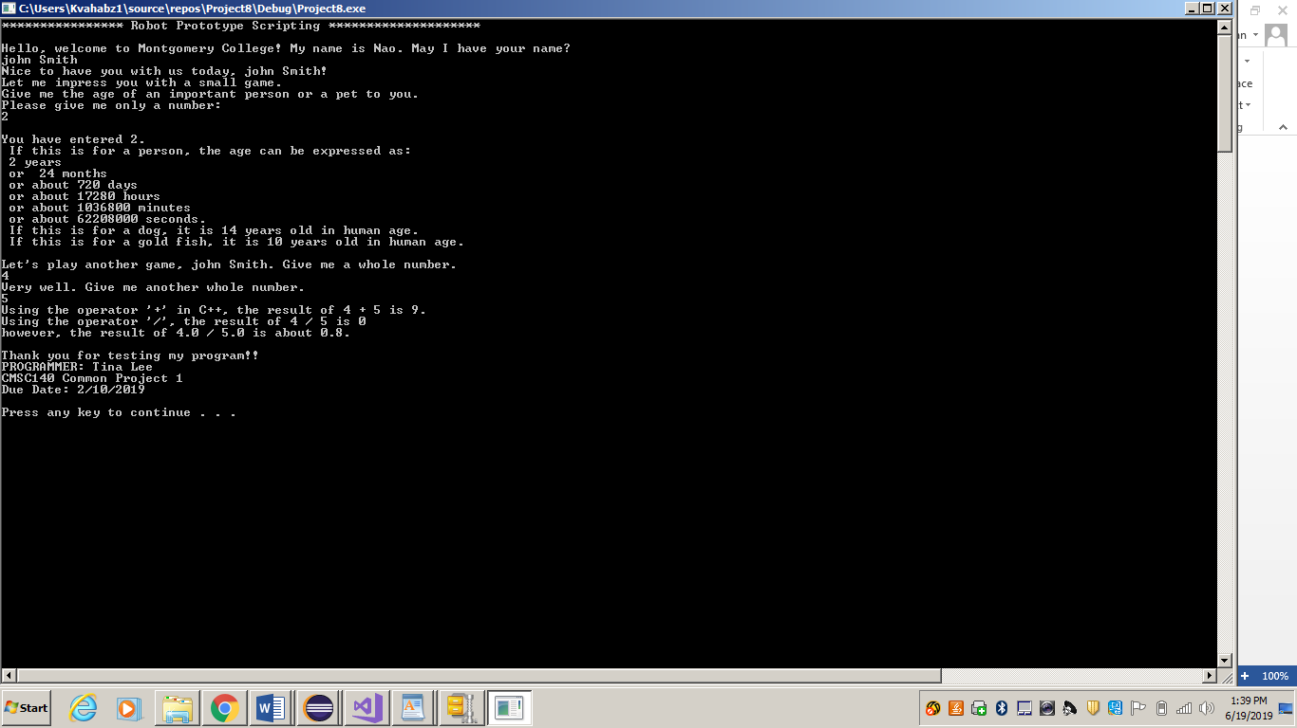

**NOTE**: Be sure to check also

1. CMSC140 Common Project Submission Requirements (.docx)
2. CMSC140 Grading Rubric_CheckList-Project 1 (.xlsx)

**Test Plan**

Test your program with at least two more test cases. Use the given data as an example. Record your data for input and output in the following table. **Make sure your tests cover all the possible scenarios.**

|  |  |  |  |  |  |
| --- | --- | --- | --- | --- | --- |
| **Test Case #** | **Input** | **Actual Input** | **Expected Output** | **Actual Output** | **Did the test pass?** |
| 1 | 2  4  5 |  | 24  720  17280  1036800  62208000  14  10  9  0  .8 |  |  |
| 2 |  |  |  |  |  |
| 3 |  |  |  |  |  |
| 4 |  |  |  |  |  |